**Question 4**

**Database design for E-commerce**

**Design an Oracle database schema for an e-commerce website ensuring data integrity, scalability and efficient query performance.**

For any **E-commerce application**, the core details we handle and store include:

1. **Authentication & User Details** – Stores customer and admin information, including login credentials, profiles, addresses, ensuring secure access management.
2. **Product Details** – Maintains product catalogs with attributes like name, category, price, description, and images to facilitate browsing and purchasing.
3. **Order Details** – Tracks customer orders, including order status, timestamps, and associated products, ensuring seamless order management.
4. **Inventory Details** – Manages stock levels, supplier details, and warehouse locations to prevent overselling and optimize supply chain operations.
5. **Payment Details** – Records transaction history, payment methods, and statuses, ensuring secure and seamless financial processing.
6. **Feedback & Recommendations** – Stores product reviews, ratings, and personalized recommendations to enhance user experience and boost sales.

**High-level Flow**

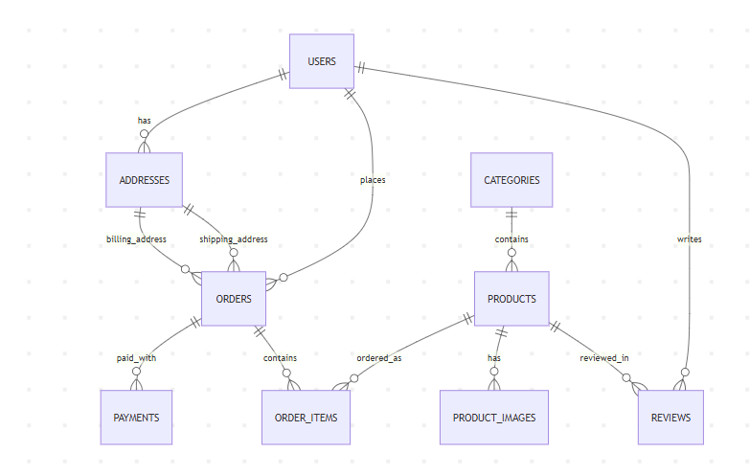

**High level Business Logic:**

1. Customers (Users) place Orders containing Products
2. Products are organized in Categories and have multiple Images
3. Customers can review Products they've purchased
4. Address management supports shipping/billing needs

**ER Diagram**

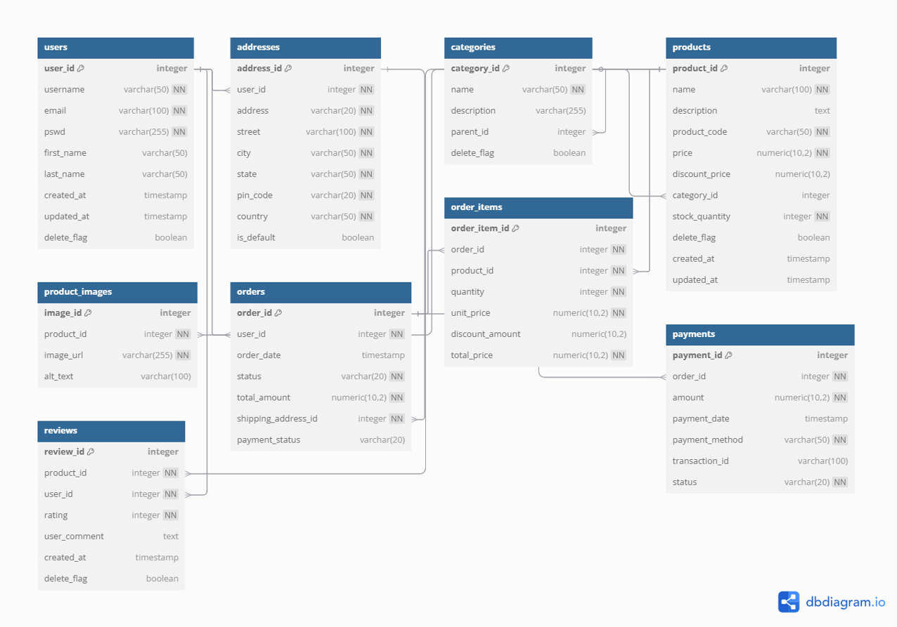

**Core Tables:**

1. **Users**
2. Stores customer account details
3. Key fields are  user_id, email, password, name fields
4. Relates to: Addresses, Orders, Reviews
5. **Addresses**
   1. Stores shipping/billing addresses
   2. Key fields: address_id, user_id (FK), address components
   3. Relates to: Users (many-to-one) and Orders
6. **Categories**
   1. Products are classification into their respective categories
   2. Key fields: category_id, name, parent_id (for subcategories)
   3. Relates to: Products (one-to-many)
7. **Products**
   1. Core product catalog
   2. Key fields: product_id, name, produce_code, pricing, category_id (FK)
   3. Relates to: Categories, Product_Images, Order_Items, Reviews
8. **Product_Images**
   1. Table to store the products images
   2. Key fields: image_id, product_id (FK), image_url, is_primary
   3. Relates to: Products (many-to-one)
9. **Orders**
   1. Stores the customer purchase details
   2. Key fields: order_id, user_id (FK), status, payment info
   3. Relates to: Users, Addresses, Order_Items
10. **Order_Items**
    1. Details of Individual products in an orders
    2. Key fields: order_item_id, order_id (FK), product_id (FK), quantity
    3. Relates to: Orders and Products
11. **Reviews**
    1. Stores the ratings/feedback
    2. Key fields: review_id, product_id (FK), user_id (FK), rating (1-5)
    3. Relates to: Products and Users

**Key Relationships:**

* **Users → Orders**: One user can place many orders
* **Products → Order_Items**: One product can appear in many orders
* **Categories → Products**: Hierarchical categorization
* **Products → Reviews**: One product can have many reviews

**Ensuring Data Integrity**

1. **Primary & Foreign Keys** – Define Primary Keys for unique identification and Foreign Keys to maintain relationships between tables, preventing orphaned records.
2. **Applying Constraints –** Enforce strict validation to maintain data consistency:
   1. **NOT NULL:** Ensures essential fields (e.g., username, email) cannot be empty.
   2. **CHECK Constraints:** Restricts values (e.g., rating between 1-5, order_status within predefined values).
   3. **UNIQUE Constraints:** Prevents duplicate values (e.g., product_code, email).
3. **Triggers for Automatic Updates** – Automate critical operations like inventory updates after an order is placed:

CREATE OR REPLACE TRIGGER trg_update_inventory

AFTER INSERT ON order_items

FOR EACH ROW

BEGIN

UPDATE products

SET stock_quantity = stock_quantity - :NEW.quantity

WHERE product_id = :NEW.product_id;

END;

/

1. **Transactions for Consistency** – Group multiple database operations into a single transaction to maintain **ACID** properties:

Example: When an order is placed, update orders, payments, and inventory together to prevent partial updates.

**Ensuring Scalability**

1. **Horizontal Scaling (Distribute Load Across Multiple Servers)**
   * **Read Replicas** – Create read-only replicas to handle reporting queries, reducing primary database load.
   * **Sharding** – Distribute large datasets across multiple database nodes to prevent bottlenecks.
2. **Connection Pooling**
   * Use **Oracle Connection Manager** to optimize database connections and improve concurrency handling.

**Optimizing Query Performance**

1. **Using Indexes to Speed Up Queries**

Create indexes on frequently queried columns to improve search efficiency:

CREATE INDEX idx_products_category ON products(category_id);

CREATE INDEX idx_orders_user ON orders(user_id);

CREATE INDEX idx_orders_status ON orders(status);

CREATE INDEX idx_order_items_order ON order_items(order_id);

1. **Fetch Only Required Data**

**Avoid SELECT \*** and retrieve only necessary columns for optimal performance:

SELECT product_name, price FROM products WHERE category_id = 10;

1. **Materialized Views for Precomputed Results**
   * Store the results of complex queries and refresh periodically to improve read performance:

CREATE MATERIALIZED VIEW mv_top_selling_products AS

SELECT product_id, SUM(quantity) AS total_sold

FROM order_items

GROUP BY product_id;

1. **Data Caching for Faster Access**

Use Oracle Result Cache or Redis to cache frequent queries like product searches, reducing database hits.

**High level ecommerce application architecture**

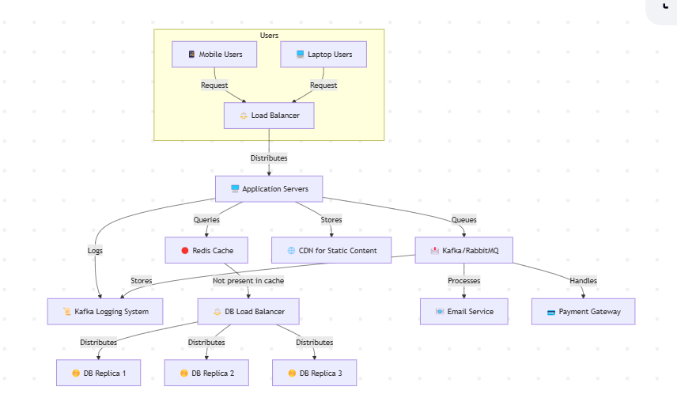

This architecture ensures scalability, efficiency, and fault tolerance for an e-commerce platform. Users (mobiles & laptops) send requests through a Load Balancer, which distributes them to multiple Application Servers. These servers first check Redis Cache for quick data retrieval and query the Database Replicas only if needed, improving performance. Kafka/RabbitMQ handles logging, email processing, and payment transactions asynchronously, reducing server load. Additionally, a second Load Balancer manages database replicas, and a CDN serves static content, ensuring faster load times.